Implementation of Breadth First Search (BFS) Using Python
Aim
To traverse a graph using the Breadth First Search (BFS) technique.
Objective
- To visit all nodes in a graph.
- To explore nodes level by level.
- To avoid revisiting nodes.
- To understand graph traversal.
- To display the BFS traversal order.
Algorithm
- Start the program.
- Create a graph.
- Select a starting node.
- Insert the starting node into a queue.
- Mark the node as visited.
- Remove a node from the queue and display it.
- Visit all unvisited adjacent nodes.
- Add adjacent nodes to the queue.
- Repeat until the queue becomes empty.
- Stop the program.
PYTHON CODE:
graph = {
'A': ['B', 'C'],
'B': ['D', 'E'],
'C': ['F'],
'D': [],
'E': [],
'F': []
}

visited = []
queue = []

start = 'A'

visited.append(start)
queue.append(start)

while queue:
node = queue.pop(0)
print(node, end=" ")

for neighbour in graph[node]:
if neighbour not in visited:
visited.append(neighbour)
queue.append(neighbour)

OUTPUT:
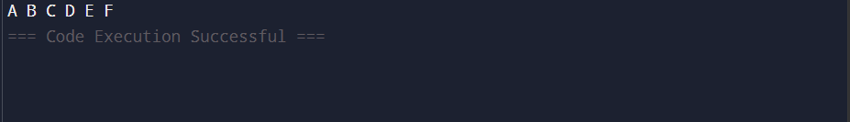

FLOW CHART:

Result
Thus, the graph was successfully traversed using Breadth First Search (BFS).

